**ECE Capstone Project**



**GreenBox**

**Zach Wilcox**

**Zacdwil@hotmail.com**

**Spring 2022**



**Table of Contents**

1. Executive Summary 2

2. Introduction 3

3. Methods 3

4. Results 3

5. Discussion 4

6. Conclusion 4

# Introduction

### **Purpose**

From the very early stages of humankind, people have been raising and caring for plants due to their many benefits. Plants help us in a wide range of ways, from providing the food necessary to live to creating a pleasant ambiance in a living room. Unfortunately, raising and caring for plants can be quite difficult for those without a “green thumb,” like myself. The GreenBox project’s purpose is to help make raising and caring for all sorts of plant life more approachable for everyone.

### **Objectives**

The overall objective of this project was to create a space with moderated temperature, humidity, air flow, and light exposure. Specifically, the GreenBox should be able to do the following:

* Measure the temperature and humidity in the chamber with 95% or greater accuracy.
* Adjust the temperature up or down as needed to bring it into the desired range as needed.
* Adjust the humidity up or down as needed to bring it into the desired range as needed.
* Turn on the lights for the desired amount of time each day.
* Turn on the fans for the desired amount of time each day.
* Show the current temperature and humidity levels on a display.

### **Approach**

The technology of environmental control is not an incredibly recent development, so my approach was to make a system using a microcontroller that would be able to control all these already existing systems in one space. It would do this by controlling the power supply to each subsystem, making it a control system that could be scaled to meet the needs of the user. However, for the purpose of this project a non-scalable, desktop-sized version was made.

# Methods

There were two methods used to monitor what needed to be adjusted: timers and sensors. The fans and lights were toggled on and off based on a timer that could be adjusted by the user input. (Note: the fans were originally going to be controlled by a CO2 sensor, but due to high complexity and time constraints were moved to a timer-based control function.) The temperature and humidity were controlled by comparing the sensor values to the user’s input values. Due to plants not needing extreme precision in temperature and humidity, the sensor was set to get a reading every 30 seconds.

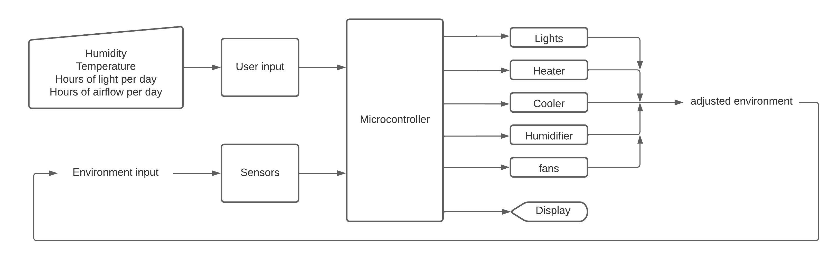

**Figure 1.** Block diagram of the system.

As stated above, the toggling of the systems was accomplished by turning the power supply on and off for each subsystem. This was accomplished using 5V relays and a control signal from the microcontroller. To ensure that each component got the correct power supply while simplifying the user experience, a power strip and an AC/DC converter were used to power all components including the microcontroller.

Though very inefficient, a Peltier cooling system was used due to a combination of low cost and the ability to do some light dehumidifying, unlike the originally intended evaporative cooler. To get a humidifier that would fit into the design, a custom-built wicking humidifier was used as opposed to a commercially sold one. For heating, a small commercial space heater was used as it was very simple and cost-effective. For similar reasons, an LED light strip was used for lighting. The fans used were basic PC fans.

The box build was originally going to be made of wood and sheet metal due to the ease of assembly and low cost. However, it was decided that the product would be more aesthetic and durable if clear acrylic and sheet metal were used. The original 2’x2’x2’ design was slightly modified to have a sloping front face to allow the door to sit in the closed position using gravity.

In the specifications document, it states that there will be two knobs for each environmental factor, one for the input level and one for how much the actual level was allowed to vary from the input level. However, it was decided that a set level of 5% error would be allowed for all factors, reducing the complexity of the user interface.

# Results

The following table uses the specifications laid out in the Project Specifications document created during the design portion of the project. For each specification, this table describes the specification briefly, shows the reference number from the Project Specifications document, indicates whether the specification was met, and shows any comments on the specification.

|  |  |  |  |  |
| --- | --- | --- | --- | --- |
| Test | Ref. # | Met | Not Met | Comments |
| No larger than 2’x2’x2’ | 4.2.1 | x |  | Verified by direct measurement |
| Weigh no more than 50lbs. | 4.2.2 | x |  | Verified by direct measurement |
| Powered by 120V 60Hz outlet. | 4.3.1 | x |  | Outlet successfully powers project. |
| Shall not cost more than $250 | 4.4.1 |  | x | Box material was more expensive than anticipated. Some components also had to be replaced due to damage. |
| User can specify temperature between 10 ◦C and 40 ◦C | 4.5.1 | x |  | Verified by demonstration. |
| User can specify accepted degree of variation | 4.5.2 |  | x | The varying degree of error specification was revised to promote simplicity and more consistent precision |
| User can specify humidity between 20% and 100% | 4.5.3 |  | x | Humidifier could not get chamber to 100% humidity. Likely due to a moderately weak humidifier and imperfect insulation. |
| User can specify accepted degree of variation | 4.5.4 |  | x | The varying degree of error specification was revised to promote simplicity and more consistent precision |
| User can specify amount of light per day | 4.5.5 | x |  |  |
| User can specify carbon dioxide levels | 4.5.6 |  | x | This specification was revised to be hours per day with air flow. |
| System blows heated or cooled air into chamber as needed | 4.6.1 | x |  | Verified by demonstration. |
| System will adjust humidity within chamber as needed | 4.6.2 |  | x | The chamber will humidify as needed, but the dehumidifying circuit is not as robust as hoped. It works in an arid environment but would not likely work in a more humid one. |
| System will light chamber for specified amount per day | 4.6.3 | x |  | Verified by demonstration. |
| System will circulate air as needed | 4.6.4 | x |  | Verified by demonstration. |
| System will display levels measured within chamber | 4.6.5 | x |  | Verified by demonstration. |
| Users shall have access to filters as needed | 4.8.1 | x |  | Verified by inspection |
| Water tank shall hold enough water to last at least 24 hours | 4.9.2 | x |  | Verified by demonstration |
| All input knobs shall be labeled | 4.10.1 | x |  | Verified by inspection |
| Bottom portion of chamber shall be resistant to soil/water | 4.11.1 | x |  | Verified by inspection |
| System shall have electrical components properly shielded from chamber | 4.12.1 | x |  | Verified by inspection |
| System shall not have any exposed wires | 4.12.2 | x |  | Verified by inspection |
| All wires shall be properly secured and protected | 4.12.3 | x |  | Verified by inspection |
| Power shall meet IEC 60035 requirements | 4.12.4 | x |  | All requirements below were verified by purchasing components that were already in line with defined specifications |
| Heater shall meet MIL-H-22577C requirements | 4.12.5 | x |  |  |
| Cooler shall meet F-C-2791 requirements | 4.12.6 | x |  |  |

# Discussion

Though many portions of the project were revised or not quite met, the overall function of the project works as intended. The chamber is heated when the temperature falls below the desired level. The chamber is cooled when temperatures rise too high. The selected cooler is not quite as effective as hoped but was a calculated risk as it saved a significant amount of money. The humidifier does its job as it should, but the dehumidifying system does not perform as well as hoped. It works well in dry environments but would likely fail in a more humid one due to much of the dehumidifying happening due to air circulation.

Unfortunately, there were several setbacks in the creation of this project, such as damaged parts and a higher difficulty level in interfacing purchased electronics with the microcontroller. The result is mostly functional with several areas needing improvement. A future version of this project would take more time to ensure top quality, particularly in the build of the box itself. A future version could also include a wireless interface to allow the user to adjust and monitor the device remotely.

# Conclusion

The project was a success. The most important functions of heating, lighting, and humidifying were successfully implemented. However, many portions such as cooling, dehumidifying, and insulation were not quite where they should have been. I was able to learn a lot on this project. Scheduling was a particular area that did not work out as well as hoped due to several setbacks but giving myself a bit more leeway in the future will help to prevent such issues.